**Assignment No-1(WEEK 1)**

-Notes:

* **ETL Process:**

1)Extract: This is the first step, where data is pulled from various sources such as Excel, CSV, text files, or database systems. It involves gathering raw data needed for analysis.

2)Transform: In this stage, the data undergoes processing, cleaning, and transformation to ensure it's usable. This includes removing inconsistencies and converting data formats.

3)Load: The cleaned and processed data is loaded into a target system like a database or a data warehouse, making it ready for analysis.

* **Analysis:**

The goal of analysis is to derive meaningful insights and facts. This is achieved by visualizing data and presenting key information through dashboards and reports.

* **Process:**

-Step 1:When we open Power BI we will see below interface.

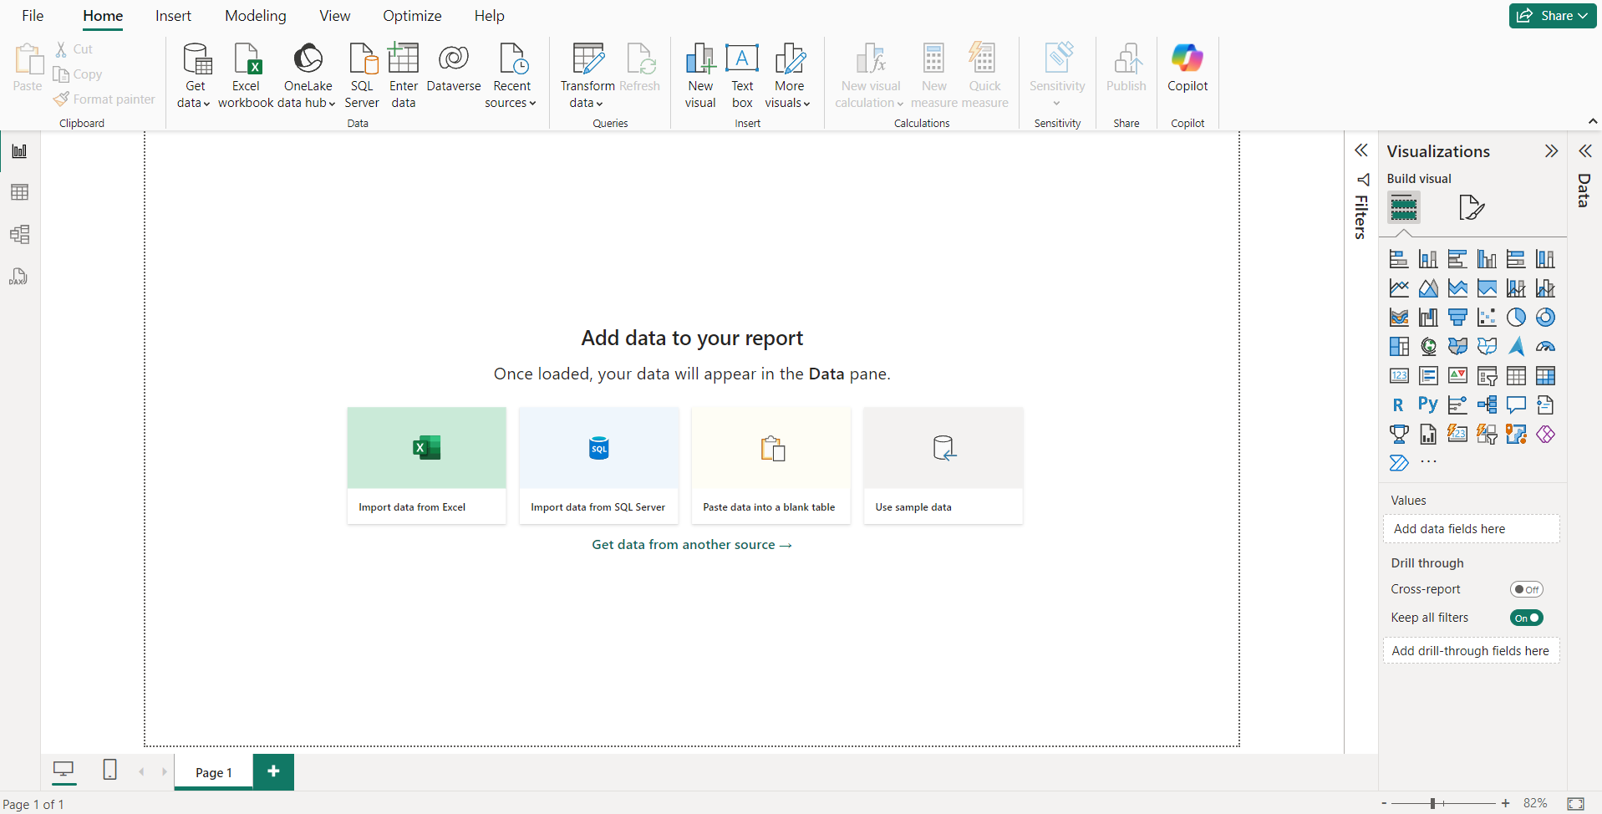

-Step 2:Now we will import our csv file by clicking on Get data -> Text/CSV.

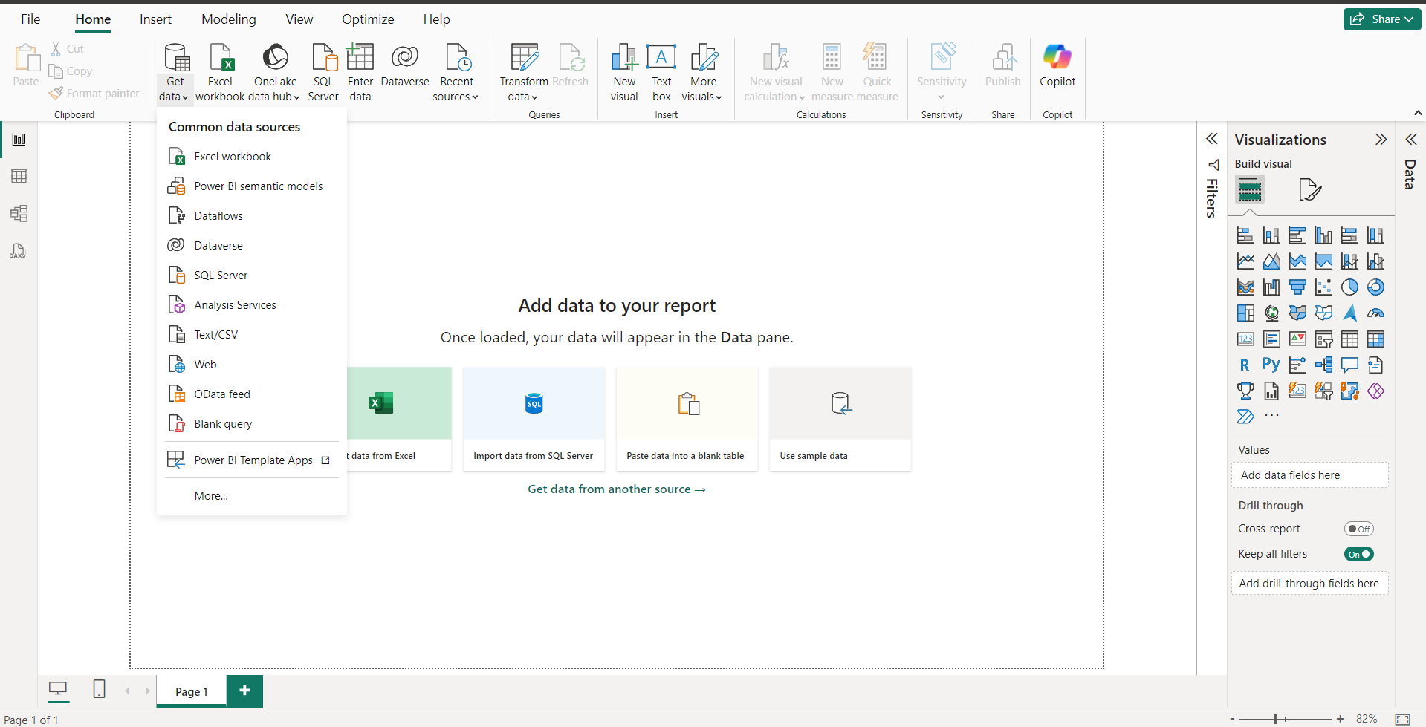

-Step 3:Now select file .

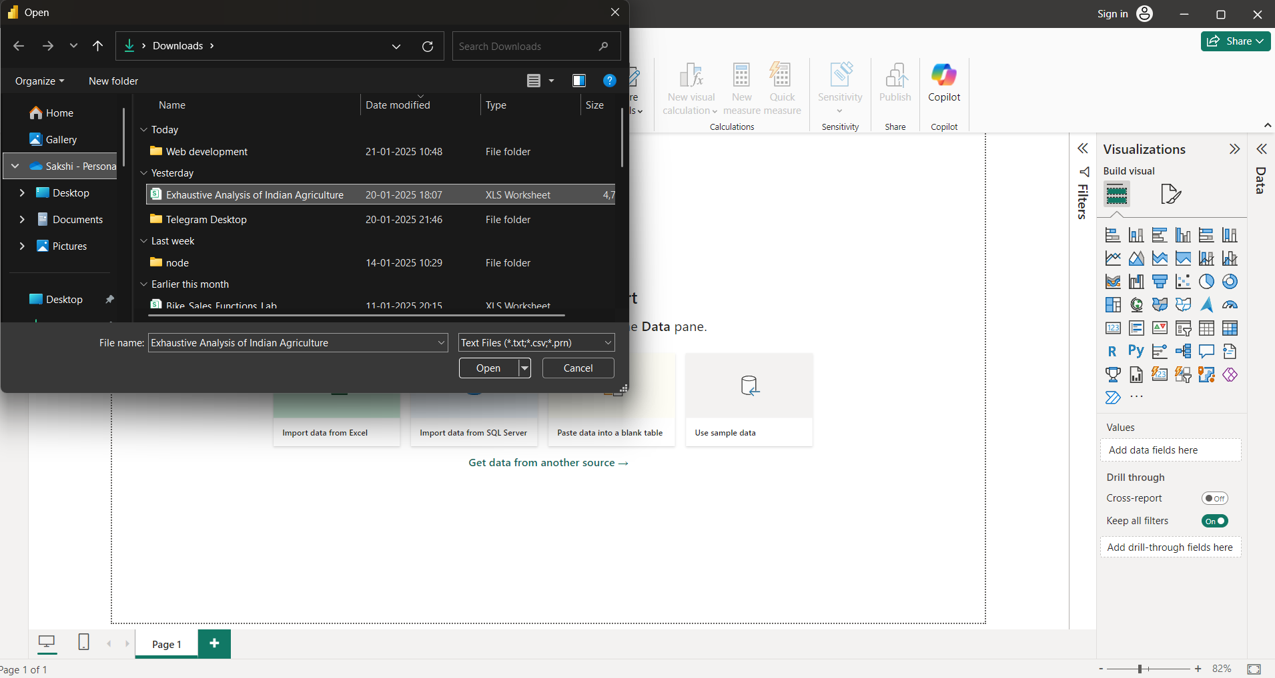

-Step 4:Click Load option if the dataset is cleaned.If dataset is not cleaned still we can click Load and afterwards we can Transform it.

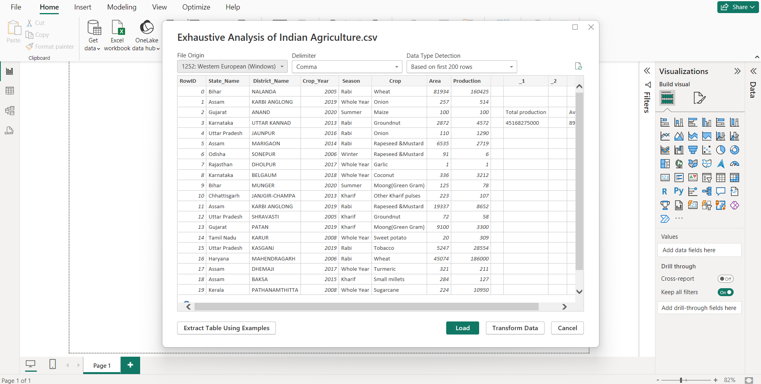

-Step 5:Now after clicking Load we will see below interface.This is Report View.

1)Report View:-Focused on visualization, where data is presented in graphs, charts, or dashboards for easier interpretation.

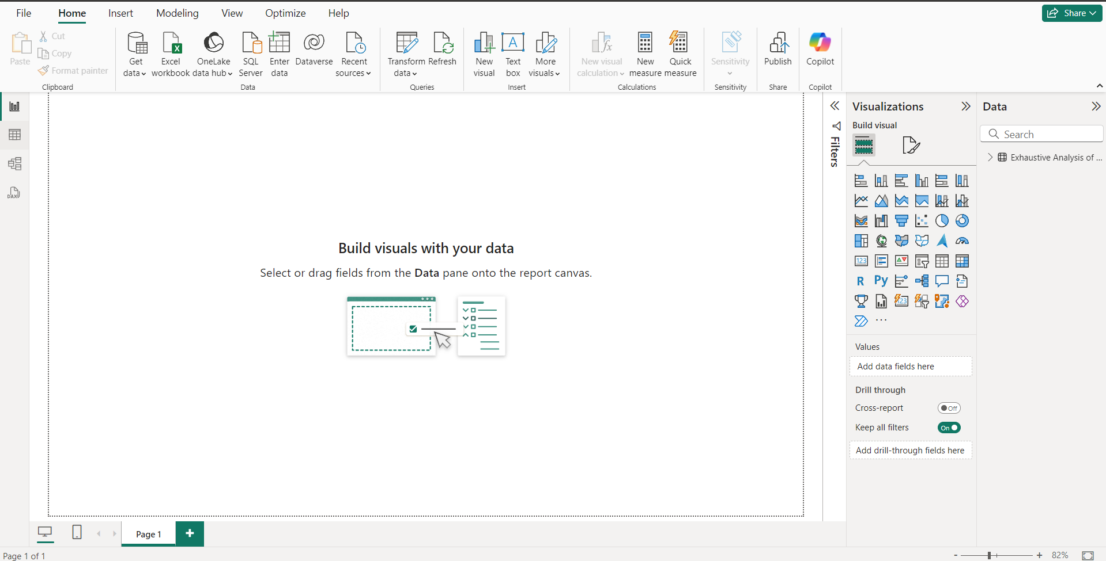

1. Table View: Displays raw data in tabular format, allowing users to view the actual data records.

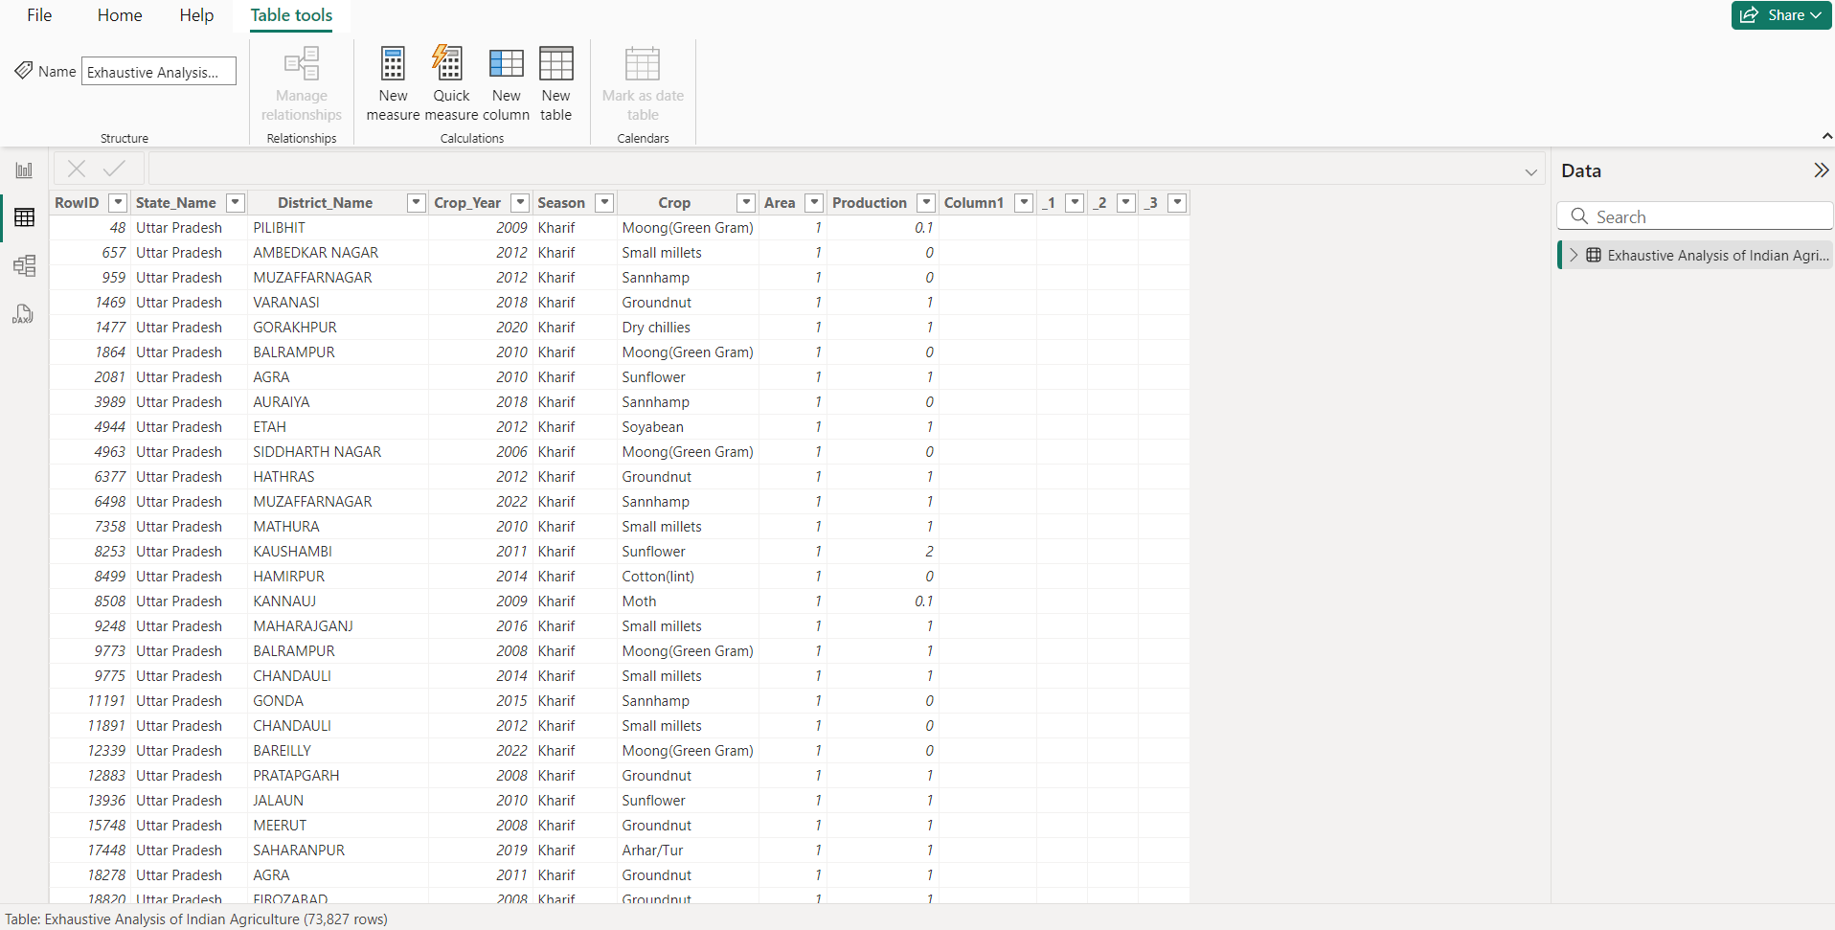

1. Model View: Provides a way to define relationships and dependencies between various datasets, enabling a structured data model.

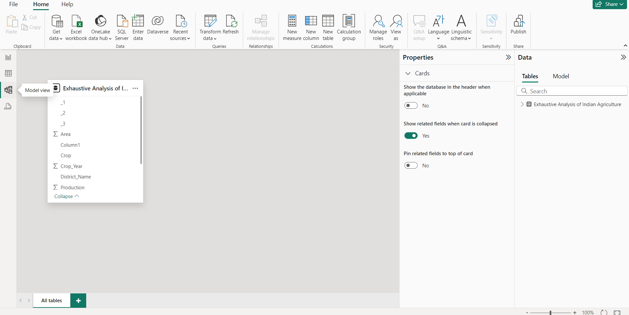

-Step 6:After clicking on Transform we will see this interface.

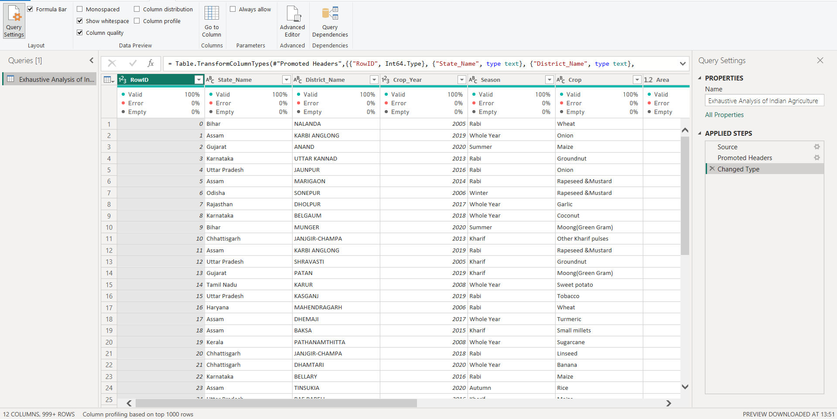

-Step 7:By right clicking on any column we will see option remove and after clicking remove the column will get delete.

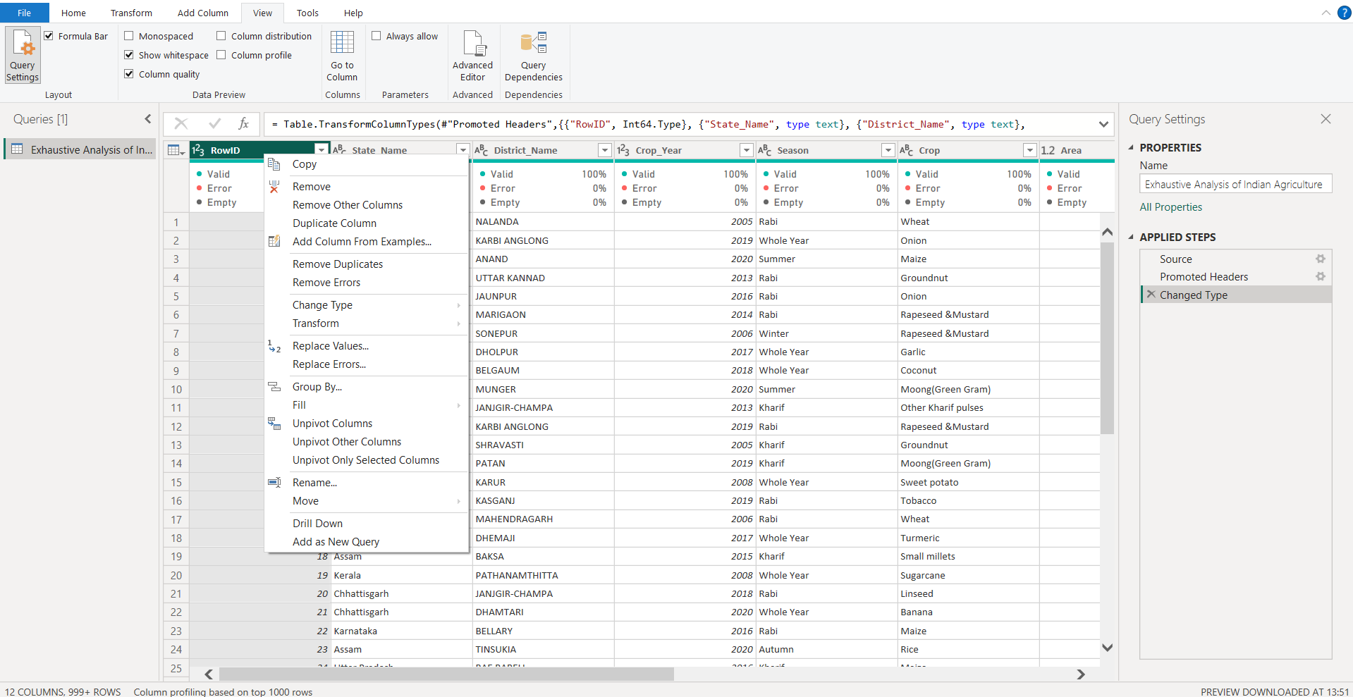

-Step 8:In View we will see Column quality by clicking that new row will get added and it will show is there any error or does the college is empty and also the validity in percentage.



-Step 9:After all the dataset is cleaned we have to click Close and Apply.

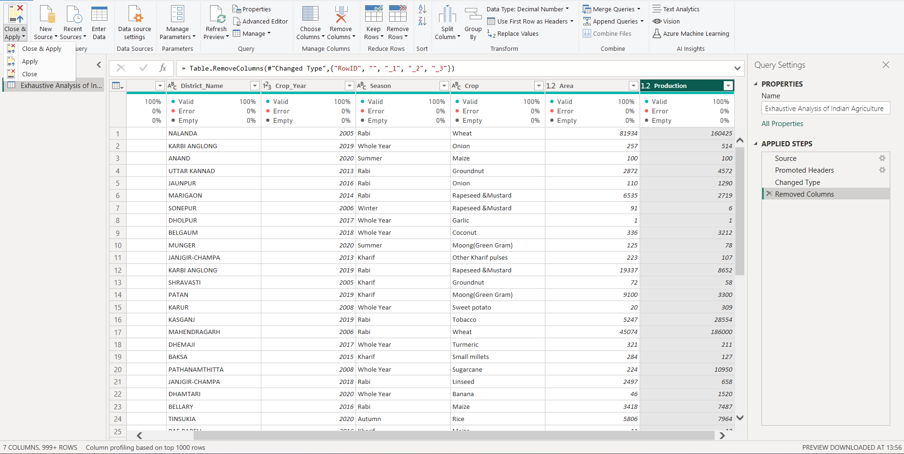

-Step 10:After that we will see the cleaned data in table view.In our dataset we have deleted 4 columns.

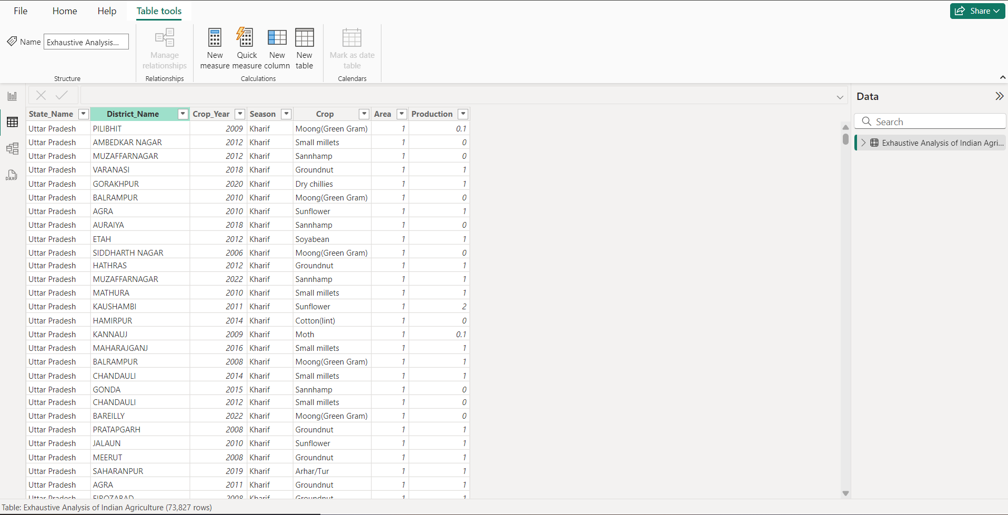

**DONE!!**